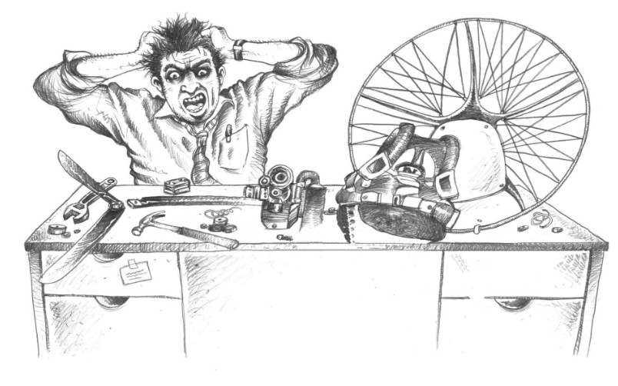

Assessing a secondhand wing and what to buy
Technical note for instructors and pilots · Version 1.0 · 30 October 2026
Paramotor SA (Pty) Ltd t/a Apex Adventures · SACAA DTO 0012

Technical notes · General

Scope. How to judge the condition and remaining life of a paraglider or paramotor wing, what the manufacturers Ozone and Dudek say about inspection, and how to decide between a new and a secondhand wing. It builds on the Apex "Assessing the Quality of a Secondhand Wing" Tech Dummy guide. Inspection figures come from the Ozone Spyder 3 and Roadster 2 manuals, the label of an Ozone Roadster 3 and the Dudek inspection pages. The figures on the wing's own label and in its own manual always win, because they differ from model to model.

1. How long does a wing last?
There is no fixed life. Manufacturers do not publish a service life in years or hours. Ozone states only that "the sail and the lines do not age in the same way or at the same rate", so part or all of the lines may need replacing during the wing's life.
As a guide, a wing made of modern non-porous fabric is often quoted at around 300 hours or about four years before it starts to deteriorate, if it is used and cared for normally. Real wings vary widely:
- Service centres report wings 15 years old still in mint condition, and wings barely two years old that are unairworthy.
- Nova's service centre in Austria has seen wings with over 500 hours in good condition and others worn out after 150 hours.
- Aerofix statistics show more failures in the lines than in the fabric.
- What counts is not only air time. Ground handling, sun (UV), heat, damp and salt all age a wing.
The effect for us: age and hours are only a starting point. The only way to know a wing's real condition is a professional inspection.

2. What the manufacturers say
Both manufacturers ask for a first inspection after 24 months or a set number of flying hours, whichever comes first. The hours differ by model, so read the label.
Item | Ozone | Dudek
First or regular full inspection | 24 months or 100 hours (Spyder 3 manual, Roadster 3 label). 24 months or 80 hours (Roadster 2 manual) | Every 24 months or 150 hours
Heavy or commercial use | Check annually if flown more than 100 hours a year | Schools and tandem: every 12 months (after the first 24 months) or every 100 hours
Who may inspect | A qualified professional or service centre | The manufacturer or an authorised dealer. Only a full inspection gives clearance to fly
After a repair | Inflate and check before flying | A post-repair inspection is mandatory
Before buying or selling | Not mentioned | An extra inspection on request

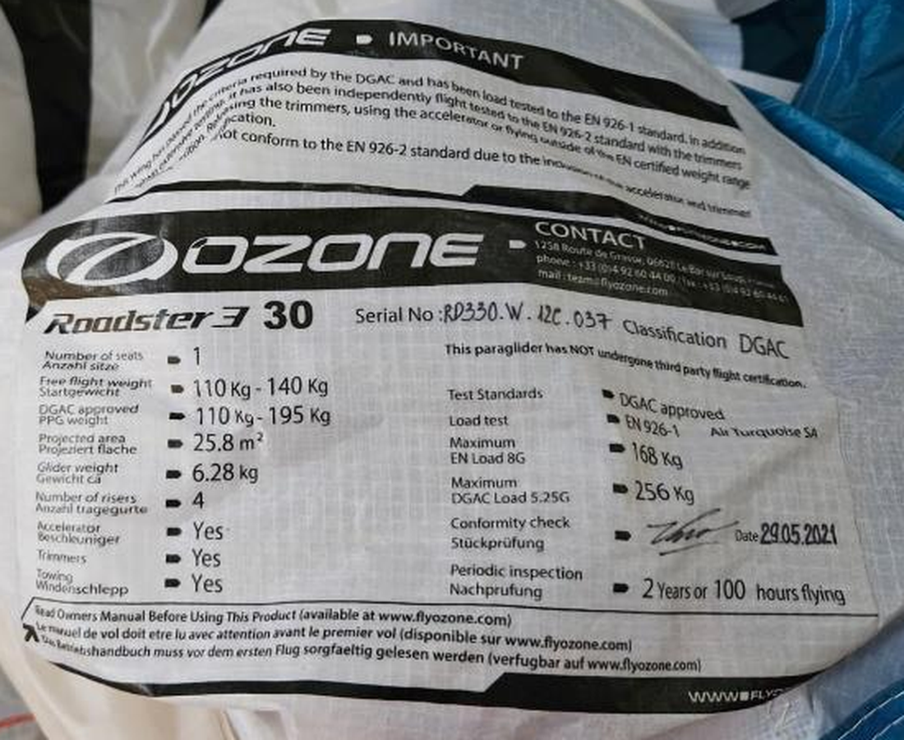
Ozone Roadster 3 size 30 label: PPG weight range 110–195 kg, free flight 110–140 kg, and "Periodic inspection: 2 years or 100 hours flying". Photo: Apex Adventures.
Intervals differ between models. Ozone gives 100 hours on the Spyder 3 and the Roadster 3 label but 80 hours in the Roadster 2 manual. Dudek gives 150 hours. Never assume. Read the label sewn into the wing and the manual for that model.

3. What a full inspection checks
The two manufacturers list almost the same tests. Together they are the checklist to ask a service centre for.
Test | What it measures | Limit given
Visual check | Stitching, ribs, diagonals, lines, tabs, risers | Any visually damaged line must be replaced (Ozone)
Cloth porosity | How much air passes through the top surface. A porous cloth loses lift and inflates badly | Ozone: time in seconds, limits on the Ozone website. Dudek: in l/m²/min. Below 300 the certificate is extended one year. 300 or more: fabric is worn and safety is uncertain
Cloth strength | Tear resistance (Bettsometer, standard TS-108) | Pass or fail by the service centre
Line strength | Break test of main lines | Ozone: minimum 14 G for the main riser lines (Spyder 3), based on maximum certified weight
Line length | Lengths under about 5 kg (5 daN) tension | Ozone: ±10 mm from original. Dudek: maximum deviation 30 mm and spread within 15 mm
Riser length | Riser lengths against the manual | Ozone: ±5 mm
Symmetry and flight test | Trim and behaviour in the air | Pass or fail by the professional

Why line length matters. Shrinking C or D lines, or stretching A or B lines, makes the wing trim slower and harder to inflate. A change in inflation, ground handling or flight behaviour indicates ageing (Ozone) and means the wing must be checked before it flies again.

Porosity: a worked example
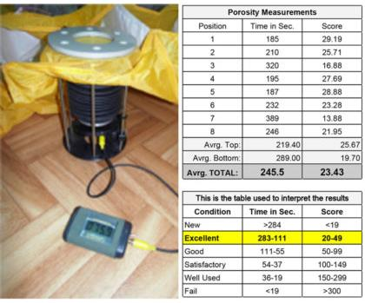
Porosity tester and a sample report in seconds, 8 measuring positions (average 245.5 s, score 23.43, "Excellent"). Source: Apex Tech Dummy guide.
The sample table in the Tech Dummy guide reads: New above 284 s, Excellent 283–111 s, Good 111–55 s, Satisfactory 54–37 s, Well used 36–19 s, Fail below 19 s. A higher time means tighter cloth. Measure at several points behind the leading edge and look at the weakest position, not only the average.
Do not mix porosity scales. Ozone-style meters read in seconds (higher is better). Dudek reports litres per square metre per minute (lower is better, 300 is the limit). The two cannot be compared. Ask the service centre which meter and which limit table it used.

Line length: a worked example
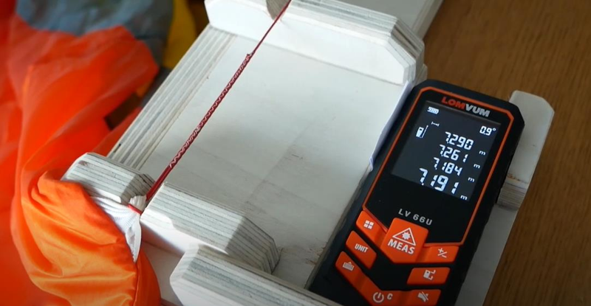
Home-made line length jig with a laser meter. Source: Apex Tech Dummy guide. Official checks use a set tension of about 5 kg.

4. New or secondhand?
Significant wing design changes come about every four to five years, so a new wing also brings newer, safer technology and a known history.

New wings
- Students train on school wings. When buying, choose a wing rated for students (from basic to high-end basic).
- A student wing should last about three years before an upgrade is needed.
- A student can train and fly only a beginner-rated wing. A high-end beginner wing is recommended for schools.

Secondhand wings
The Tech Dummy price guide below is a fair-use guide only. It is not a valuation. It depends on the inspector's certified condition.
Age | Hours | Fair price (% of new) | Inspector's condition
1 year | 10–20 | 70% | As new
2–3 years | about 50 | 50% | Very good
3–4 years | about 100 | 40% | Good
4–5 years | 150–200 | 30% | Fair
5–10 years | 200+ | 20% | Used

- A wing older than 10 years, or with a report of "Used" or "Heavily used", is not recommended.
- A wing of 2–3 years with high hours is worth about 30–40% of new and must pass an inspection at an approved service centre.
- Apex rule: no student is trained on a secondhand wing older than two years without a proper inspection or certificate.

5. Before you buy a secondhand wing
- Get the facts. Model, size, year of manufacture (on the label), serial number, total hours, how it was used (training, tandem, coast, desert) and every repair.
- Check the label. Weight range (PPG and free flight), certification class, date and the periodic inspection interval. Make sure it matches the pilot and the use.
- Look at it laid out. Check the cloth for sun-fade, stiffness, stains, mould, salt marks, tears and burn marks. Check stitching, tabs, risers and the line colours for stretch or fraying.
- Ask for the inspection report. Look at the date, the porosity result and the line lengths. A wing with no records should be treated as unknown.
- Have it inspected before you pay. Use the manufacturer or an authorised dealer (Dudek offers an extra inspection on request, for example before buying or selling). Make the sale depend on the result.
- Check it was repaired and re-inspected. Dudek requires a post-repair inspection after every repair.
- Ask your instructor. Use the school's brands and their experience. Confirm the wing suits the pilot, weight range, course and budget before you commit.
Walk away if: the wing is older than 10 years, has no records, fails or is refused inspection, the lines have been replaced with non-original material, or the seller will not allow an inspection.

6. Weight range and wing loading
- Stay inside the wing's certified range. Never fly above the recommended maximum PPG weight (Ozone).
- Lightly loaded wings react more slowly and less severely to collapses and in-flight events.
- Heavily loaded wings are more pressurised, so collapses are less frequent but more severe.
- High altitude (Gauteng, about 4,800 ft): aim for about 50% through the wing's range. Sea level: about 70–80% through the range.
- Example (label above): Roadster 3 size 30, PPG 110–195 kg. The "50% point" is about 152 kg all-up weight.

7. Looking after the wing
- Heat and damp together are the worst enemy. Never pack or store a wing wet. Dry it in the wind, out of the sun, never with a hair dryer. Never leave it in a hot car.
- Sun (UV): pack the wing away after flying and do not leave it in the sun.
- Salt: rinse with clean fresh water after sea air or water. Salt damages cloth, stitching and lines.
- Ground handling in strong wind, sand and rocks speeds up wear.
- Cleaning: a soft cloth with water only. No detergents or chemicals.
- Insects: shake them out before packing, as they can damage the cloth.
- Service it yearly and after any incident or long storage.

8. Secondhand wing assessment record
Copy one line per wing assessed.
Date | Wing, size, serial | Age and hours | Porosity result | Lines (mm) | Inspected by | CFI decision

9. Sources and cautions
- Assessing the Quality of a Secondhand Wing and what to Buy (Apex Adventures Tech Dummy guide). Life, price table, buying rules, loading. It cites XC Mag (15 Jan 2022), Walland Air, Aerofix and Nova service centres.
- Ozone Spyder 3 manual v1.2 and Roadster 2 manual (Ozone Paragliders). Inspection interval, tests, line and riser tolerances, care.
- Ozone Roadster 3 size 30 wing label (photo, Apex Adventures). PPG weight range and periodic inspection "2 years or 100 hours".
- Full Inspection page and inspection overview (Dudek Paragliders, dudek.eu). Interval, commercial use, tests, porosity, line length, who may inspect.
Cautions.
- Prices and condition grades are a guide from the Tech Dummy guide and not published manufacturer data.
- Ozone and Dudek figures apply to their own wings. Other brands (Nova, Advance, Niviuk and others) set their own intervals and limits.
- Check that a service centre is authorised for that brand. Dudek states that only the manufacturer or an authorised dealer may inspect its wings.
- This note is a technical aid. It does not replace the manufacturers' manuals or the DTO's procedures.
Reviewed and approved by CFI: ___________________________ Date: _____________

